**INFOSYS SPRINGBOARD PROJECT**

TITLE: PYTHON-BASED ONLINE EVENT MANAGEMENT SYSTEM

**Abstract:**

This project entails the development of an online event management system using Python as the backend and HTML, CSS, JavaScript, and Bootstrap for the front end. The system aims to streamline event organization and management by implementing various modules including User Authentication and Registration, Appointment Scheduling Interface, Hall Availability Management, Booking Information Management, Appointment Management, Notification System, and Admin Dashboard. Through this project, users will experience a user-friendly interface while organizers and administrators benefit from efficient event planning and monitoring capabilities.

**Project Explanation**:

The online event management system project leverages a combination of frontend technologies such as HTML, CSS, JavaScript, and Bootstrap, along with Python for the backend, to create a comprehensive platform for event organization. Each module plays a crucial role in facilitating different aspects of event management.

**User Authentication and Registration**: Users will be able to securely register and authenticate themselves to access the system, ensuring data integrity and user privacy.

**Appointment Scheduling Interface**: This module will facilitate the scheduling of appointments for events, allowing organizers to set available time slots and attendees to book appointments accordingly.

**Hall Availability Management**: The system will manage the availability of event halls or venues, providing real-time updates on hall bookings and availability status.

**Booking Information Management**: Users can view and manage their event bookings, including modifying or canceling appointments as needed.

**Appointment Management**: Organizers will have tools to efficiently manage appointments, such as approving or rejecting appointment requests, sending reminders, and updating event details.

**Notification System:** A comprehensive notification system will be integrated to send timely alerts and reminders to users about upcoming appointments, changes in schedules, or other relevant information.

**Admin Dashboard**: An intuitive dashboard will be provided for administrators to oversee the system's operations, manage user accounts, monitor bookings, generate reports, and perform other administrative tasks efficiently.

Through the implementation of these modules, the proposed online event management system will offer a seamless and efficient solution for organizing and managing events, catering to the needs of both event organizers and attendees. Python's versatility and extensive libraries make it an ideal choice for developing such a sophisticated system, promising reliability, scalability, and ease of maintenance.

**UML DIAGRAM:**

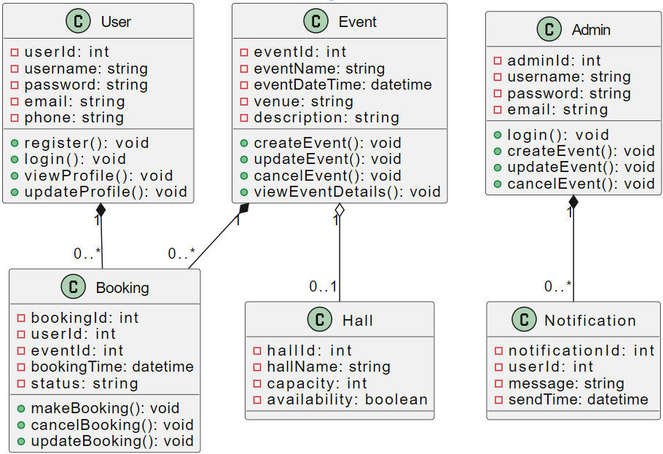

**DFD DIAGRAM:**

